c) 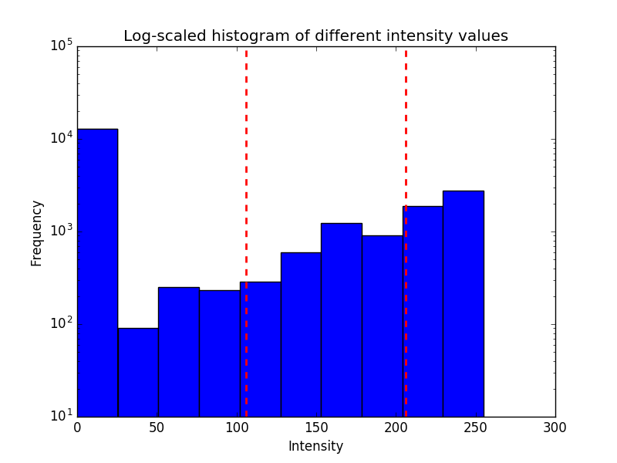

Background separating threshold 106

Gray matter from white matter separating threshold 206

Thresholds: 106 206

Intensity value 0 to 106 showing the background – Black.

106 to 206 showing the gray matter – gray matter

206 to above showing the white matter – white matter

f)

There is not that much difference while upmasking the interpolated original image. The masks from the bilinear interpolation, the images are smoother. In the nearest neighbor method it’s also almost same.